A000-US-OK-Cheyenne-Child’s War Club-19th c

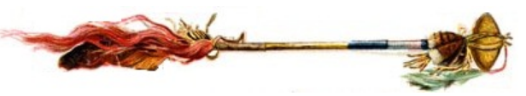

An artistic reconstruction of its appearance, when hafted on a stem

**Case no.: 13**

**Accession Number:**

**Formal Label:** US-OK-Cheyenne-Child’s War Club-19th c

**Display Description:**

This weapon was used either as a more traditional war club (for bludgeoning an enemy using a swinging action) or as a throwing weapon. The size of this example has led to its being identified as a child’s war club. A groove was often ground around the stone in order to create a haft around which it could be bound to a handle with wet rawhide. When the rawhide dried it would tighten to inflexibility and offer a secure haft.

**LC Classification:**

**Date or Time Horizon:**

**Geographical Area:**

**Map:**

**GPS coordinates:**

**Cultural Affiliation:**

**Media:** **Dimensions:**

**Weight:**

**Condition:**

**Provenance:**

**Discussion:**

**References:**